

**Virtual classroom website**



**Supervisor:**

dr. Kamal Al-Sallom

**INTRODUCED BY STUDENTS:**

Elias Awess

Hassan Eid

Ammar Shalab Al-Sham

Mostafa Audah

Year: 2019/2020

# **Project Objectives:**

## **Introduction:**

Virtual Classroom is an online teaching and learning environment where teachers and students can share and interact with course materials.

Our project is a simple virtual classroom website that help teacher to create course and share course materials with their students.

There are 2 objectives of this project: communication and organization.

## **Commuincation:**

Mean teachers and students can communicate with each other to provide comfortable environment for study, so student can ask questions and answer teacher’s question during each lesson.

## **Oroganization:**

Mean teacher can organize course materials to provide reliable reference to course subject.

Teacher can also share support files and links for more information.

# **Design Pattern: MVC**

Stands for "Model-View-Controller".

MVC is an application design model comprised of three interconnected parts. They include the model (data), the view (user interface), and the controller (processes that handle input).

The MVC model or "pattern" is commonly used for developing modern user interfaces. It provides the fundamental pieces for designing a program for desktop or mobile, as well as web applications.   
It works well with object-oriented programming, since the different models, views, and controllers can be treated as objects and reused within an application.

Below is a description of each aspect of MVC:

1. Model

A model is data used by a program. This may be a database, file, or a simple object, such as an icon or a character in a video game.  
so we define a part of the project to deal with database and file system and other parts request data and files from it.

2. View

A view is the means of displaying objects within an application. Examples include displaying a window or buttons or text within a window. It includes anything that the user can see.

3. Controller

A controller updates both models and views.   
It accepts input and performs the corresponding update.   
For example, a controller can update a model by changing the attributes of a character in a video game. It may modify the view by displaying the updated character in the game.   
the controller is considered as a mean between view and model.

The three parts of MVC are interconnected.   
The view displays the model for the user.   
The controller accepts user input and updates the model and view accordingly.   
While MVC is not required in application design, many programming languages and IDEs support the MVC architecture, making it a common choice for developers.

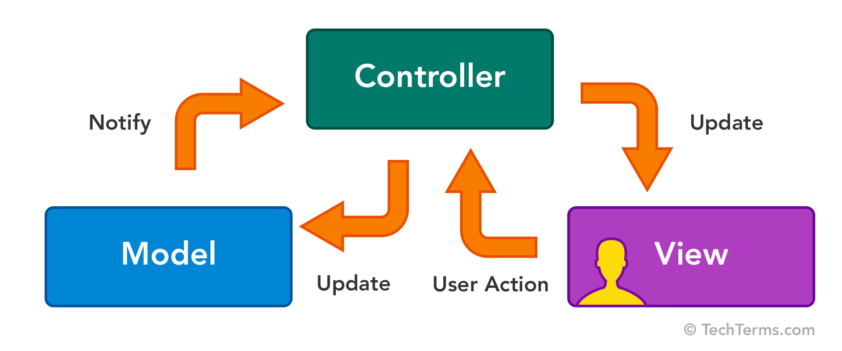

Reference: <https://techterms.com/definition/mvc>

# **Development Tools:**

## **MEAN STACK Web Development:**

**What is MEAN?**

MEAN is a full-stack JavaScript solution that helps you build fast, robust, and maintainable production web applications using MongoDB, Express, Angular, and Node.js.

**Why MEAN?**

MEAN.JS will help you getting started and avoid useless grunt work and common pitfalls, while keeping your application organized.

## **MongoDB: (NoSQL Database)**

Not Only SQL Database

MongoDB is a general purpose, document-based, distributed database built for modern application developers and for the cloud era.

**MongoDB Features:**

1. As a programmer, you think in objects.   
   Now your database does too.  
   MongoDB is a document database, which means it stores data in JSON-like documents.
2. Rich JSON Documents  
   The most natural and productive way to work with data.  
   Supports arrays and nested objects as values.  
   Allows for flexible and dynamic schemas.
3. Powerful query language  
   Rich and expressive query language that allows you to filter and sort by any field, no matter how nested it may be within a document.  
   Support for aggregations and other modern use-cases such as geo-based search, graph search, and text search.  
   Queries are themselves JSON, and thus easily composable.   
   No more concatenating strings to dynamically generate SQL queries.
4. All the power of a relational database, and more...  
   Distributed multi-document ACID (atomicity, consistency, isolation, durability) transactions with snapshot isolation (all reads made in a transaction will see a consistent snapshot of the database).  
   Support for joins in queries.  
   Two types of relationships instead of one: reference and embedded.

Reference: <https://www.mongodb.com>

## **Express JS:**

ExpressJS is Fast, unopinionated, minimalist web framework for Node.js

It used for building Web Applications and APIs.

For Web Application:

Express is a minimal and flexible Node.js web application framework that provides a robust set of features for web and mobile applications.

For API:

With a myriad of HTTP utility methods and middleware at your disposal, creating a robust API is quick and easy.

ExpressJS provides mechanisms to:

* Write handlers for requests with different HTTP verbs at different URL paths (routes).
* Integrate with "view" rendering engines in order to generate responses by inserting data into templates.
* Set common web application settings like the port to use for connecting, and the location of templates that are used for rendering the response.
* Add additional request processing "middleware" at any point within the request handling pipeline.
* Use third-party libraries to add more features to your apps.

Reference: <https://expressjs.com/>

## **Angular:**

Angular is a platform and framework for building single-page client applications using HTML and TypeScript.   
It implements core and optional functionality as a set of TypeScript libraries that you import into your apps.

**Angular Features:**

1. Develop Across All Platforms:

Learn one way to build applications with Angular and reuse your code and abilities to build apps for any deployment target. For web, mobile web, native mobile and native desktop.

1. Speed & Performance:

Achieve the maximum speed possible on the Web Platform today, and take it further, via Web Workers and server-side rendering.  
Angular puts you in control over scalability.

1. Incredible Tooling:

Build features quickly with simple, declarative templates.   
Extend the template language with your own components and use a wide array of existing components.   
Get immediate Angular-specific help and feedback with nearly every IDE and editor.   
All this comes together so you can focus on building amazing apps rather than trying to make the code work.

Reference: <https://angular.io>

## **NodeJS:**

Node.js is an asynchronous event-driven JavaScript runtime.   
Node.js used to run javascript outside the browser.  
Node.js is designed to build scalable network applications.

In Node.js many connections can be handled concurrently.   
Upon each connection, the callback is fired, but if there is no work to be done, Node.js will sleep.  
This is in contrast to today's more common concurrency model, in which OS threads are employed. Thread-based networking is relatively inefficient and very difficult to use. Furthermore, users of Node.js are free from worries of dead-locking the process, since there are no locks. Almost no function in Node.js directly performs I/O, so the process never blocks. Because nothing blocks, scalable systems are very reasonable to develop in Node.js.

Node.js is similar in design to, and influenced by, systems like Ruby's Event Machine and Python's Twisted. Node.js takes the event model a bit further. It presents an event loop as a runtime construct instead of as a library. In other systems, there is always a blocking call to start the event-loop. Typically, behavior is defined through callbacks at the beginning of a script, and at the end a server is started through a blocking call like EventMachine::run(). In Node.js, there is no such   
start-the-event-loop call. Node.js simply enters the event loop after executing the input script. Node.js exits the event loop when there are no more callbacks to perform. This behavior is like browser JavaScript — the event loop is hidden from the user.

HTTP is a first-class citizen in Node.js, designed with streaming and low latency in mind. This makes Node.js well suited for the foundation of a web library or framework.

Node.js being designed without threads doesn't mean you can't take advantage of multiple cores in your environment.   
Child processes can be spawned by using our child_process.fork() API, and are designed to be easy to communicate with.   
Built upon that same interface is the cluster module, which allows you to share sockets between processes to enable load balancing over your cores.

Reference: <https://nodejs.org/en/about/>

# **Academic Research: SEO**

## **What is Search Engine Optimization (SEO)?**

SEO stands for Search Engine Optimization, which is the practice of increasing the quantity and quality of traffic to your website through organic search engine results.

To understand the true meaning of SEO, let's break that definition down and look at the parts:

1. Quality of traffic:   
   You can attract all the visitors in the world, but if they're coming to your site because Google tells them you're a resource for Apple computers while you're really a farmer selling apples, that is not quality traffic. Instead you want to attract visitors who are genuinely interested in products that you offer.
2. Quantity of traffic:   
   Once you have the right people clicking through from those search engine results pages (SERPs), more traffic is better.
3. 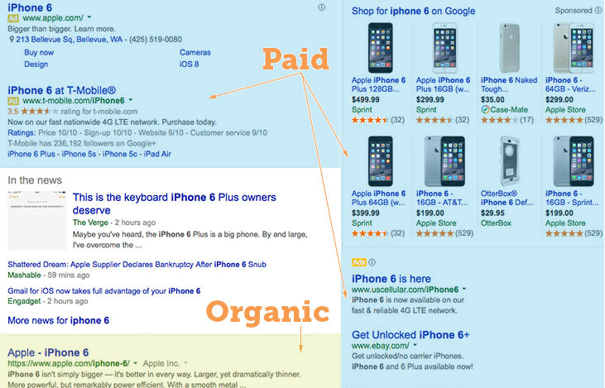Organic results:   
   Ads make up a significant portion of many SERPs.   
   Organic traffic is any traffic that you don't have to pay for.

## **How Search Engine Work?**

search engines are answer machines.   
They exist to discover, understand, and organize the internet's content in order to offer the most relevant results to the questions searchers are asking.

Search engines have three primary functions:

1. Crawl.
2. Index.
3. Rank.

### **Crawl:**

Crawling is the discovery process in which search engines send out a team of robots (known as crawlers or spiders) to find new and updated content.   
Content can vary — it could be a webpage, an image, a video, a PDF, etc. — but regardless of the format, content is discovered by links.

### **Index:**

Store and organize the content found during the crawling process.   
Once a page is in the index, it’s in the running to be displayed as a result to relevant queries.  
Search engines process and store information they find in an index,   
a huge database of all the content they’ve discovered and deem good enough to serve up to searchers.

### **Rank:**

Provide the pieces of content that will best answer a searcher's query, which means that results are ordered by most relevant to least relevant.  
In general, you can assume that the higher a website is ranked, the more relevant the search engine believes that site is to the query.

Reference: <https://moz.com>

## **Google Search Engine:**

Every time you search, there are thousands, sometimes millions, of webpages with helpful information. How Google figures out which results to show starts long before you even type, and is guided by a commitment to you to provide the best information.

Before you search, web crawlers gather information from across hundreds of billions of webpages and organize it in the Search index.

The fundamentals of Search:

The crawling process begins with a list of web addresses from past crawls and sitemaps provided by website owners.   
As google crawlers visit these websites, they use links on those sites to discover other pages. The software pays special attention to new sites, changes to existing sites and dead links.   
Computer programs determine which sites to crawl, how often and how many pages to fetch from each site.  
google offer Search Console to give site owners granular choices about how Google crawls their site: they can provide detailed instructions about how to process pages on their sites, can request a recrawl or can opt out of crawling altogether using a file called “robots.txt”.   
Google never accepts payment to crawl a site more frequently — google provide the same tools to all websites to ensure the best possible results for the users.

Finding information by crawling:

The web is like an ever-growing library with billions of books and no central filing system. google use software known as web crawlers to discover publicly available webpages.   
Crawlers look at webpages and follow links on those pages, much like you would if you were browsing content on the web.   
They go from link to link and bring data about those webpages back to Google’s servers.

Organizing information by indexing:

When crawlers find a webpage, google systems render the content of the page, just as a browser does. google take note of key signals   
— from keywords to website freshness — and we keep track of it all in the Search index.

The Google Search index contains hundreds of billions of webpages and is well over 100,000,000 gigabytes in size. It’s like the index in the back of a book — with an entry for every word seen on every webpage google index. When google index a webpage, google add it to the entries for all of the words it contains.

With the Knowledge Graph, we’re continuing to go beyond keyword matching to better understand the people, places and things you care about. To do this, google not only organize information about webpages but other types of information too.   
Today, Google Search can help you search text from millions of books from major libraries, find travel times from your local public transit agency, or help you navigate data from public sources like the World Bank.

**How Search algorithms work:**

With the amount of information available on the web, finding what you need would be nearly impossible without some help sorting through it. Google ranking systems are designed to do just that: sort through hundreds of billions of webpages in Search index to find the most relevant, useful results in a fraction of a second, and present them in a way that helps you find what you’re looking for.

These ranking systems are made up of not one, but a whole series of algorithms. To give you the most useful information, Search algorithms look at many factors, including the words of your query, relevance and usability of pages, expertise of sources, and your location and settings. The weight applied to each factor varies depending on the nature of your query—for example, the freshness of the content plays a bigger role in answering queries about current news topics than it does about dictionary definitions.

the key factors that help determine which results are returned for your query:

1. Meaning of your query  
   To return relevant results for your query, google first need to establish what information you’re looking for and the intent behind your query. Understanding intent is fundamentally about understanding language, and is a critical aspect of Search.   
   google build language models to try to decipher what strings of words should look up in the index.  
   This involves steps as seemingly simple as interpreting spelling mistakes, and extends to trying to understand the type of query you’ve entered by applying some of the latest research on natural language understanding.   
     
   For example, google synonym system helps Search know what you mean by establishing that multiple words mean the same thing. This capability allows Search to match the query   
   “How to change a lightbulb” with pages describing how to replace a lightbulb. This system took over five years to develop and significantly improves results in over 30% of searches across 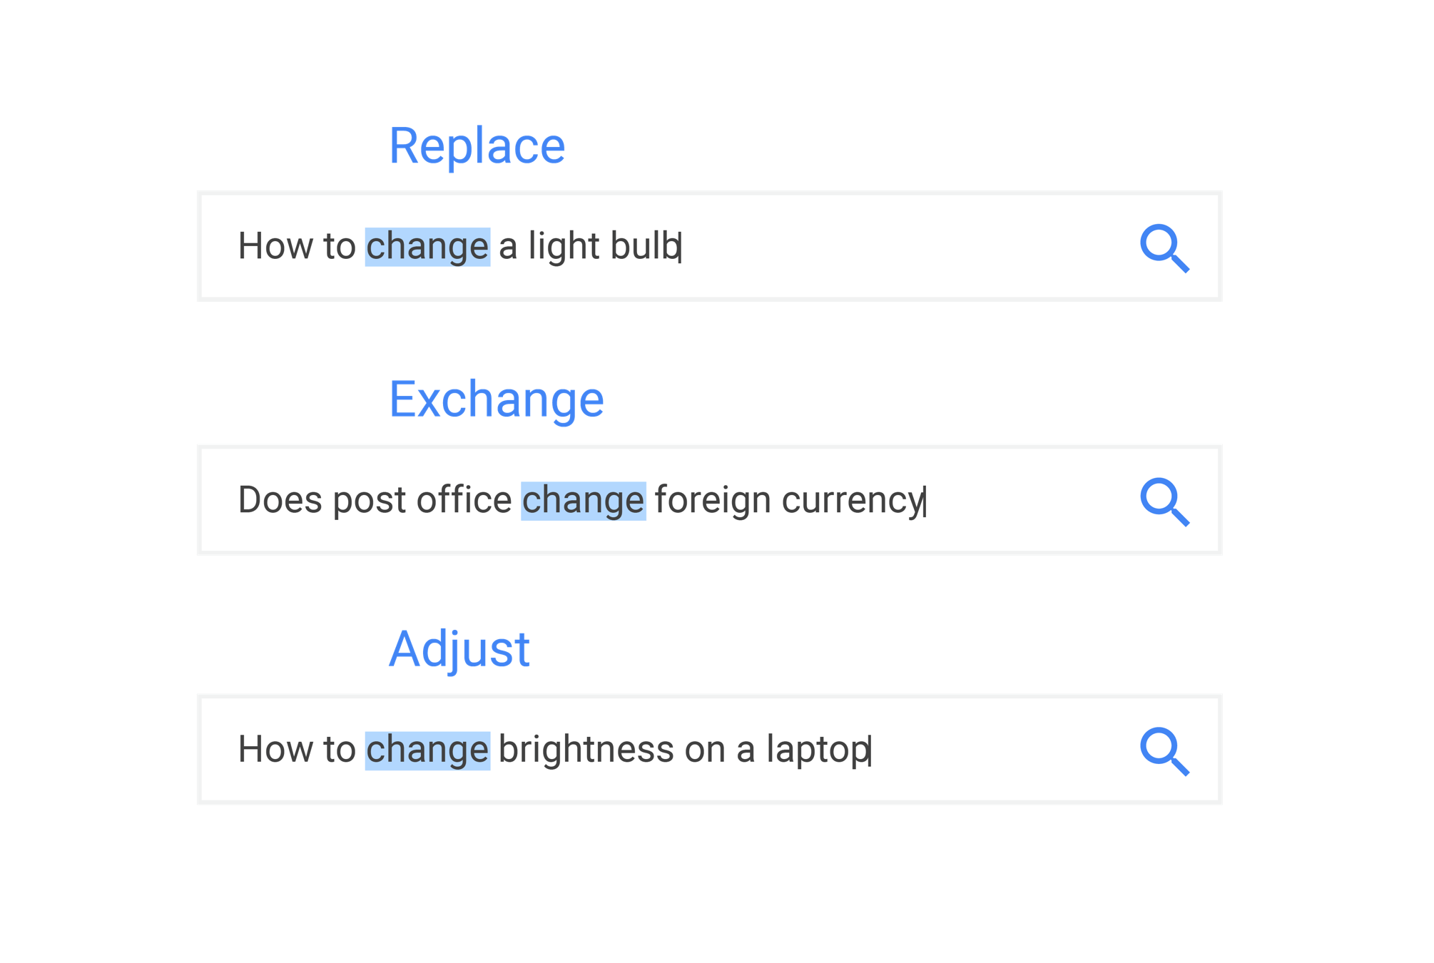languages.  
     
   Beyond synonyms, Search algorithms also try to understand what category of information you are looking for. Is it a very specific search or a broad query? Are there words such as “review” or “pictures” or “opening hours” that indicate a specific information need behind the search? Is the query written in French, suggesting that you want answers in that language?   
   Or are you searching for a nearby business and want local info?  
   A particularly important dimension of this query categorization is our analysis of whether your query is seeking out fresh content.   
   If you search for trending keywords, algorithms will interpret that as a signal that up-to-date information might be more useful than older pages.
2. Relevance of webpages:

Next, algorithms analyze the content of webpages to assess whether the page contains information that might be relevant to what you are looking for.

The most basic signal that information is relevant is when a webpage contains the same keywords as your search query. If those keywords appear on the page, or if they appear in the headings or body of the text, the information is more likely to be relevant. Beyond simple keyword matching, google use aggregated and anonymized interaction data to assess whether search results are relevant to queries. google transform that data into signals that help machine-learned systems better estimate relevance.

These relevance signals help Search algorithms assess whether a webpage contains an answer to your search query, rather than just repeating the same question. Just think: when you search for “dogs”, you likely don’t want a page with the word “dogs” on it hundreds of times. With that in mind, algorithms assess if a page contains other relevant content beyond the keyword “dogs” — such as pictures of dogs, videos, or even a list of breeds.

It’s important to note that, while our systems do look for these kind of quantifiable signals to assess relevance, they are not designed to analyze subjective concepts such as the viewpoint or political leaning of a page’s content.

1. Quality of content:

Beyond matching the words in your query with relevant documents on the web, Search algorithms also aim to prioritize the most reliable sources available. To do this, google systems are designed to identify signals that can help determine which pages demonstrate expertise, authoritativeness, and trustworthiness on a given topic.

google look for sites that many users seem to value for similar queries. For example, if other prominent websites link to the page (what is known as PageRank), that has proven to be a good sign that the information is well trusted. Aggregated feedback from Search quality evaluation process is used to further refine how systems discern the quality of information.

Spam algorithms play an important role in establishing whether a page is low-quality and help Search ensure that sites don’t rise in search results through deceptive or manipulative behavior. Google’s webmaster guidelines outline the techniques that characterize such low-quality spam sites, including buying links that pass PageRank or sneaking invisible text onto the page.

Content on the web and the broader information ecosystem is constantly changing, and we continuously measure and assess the quality of systems to ensure that we’re achieving the right balance of information relevance and authoritativeness to maintain your trust in the results you see.

1. Usability of webpages:

When ranking results, Google Search also evaluates whether webpages are easy to use. When google identify persistent user pain points, google develop algorithms to promote more usable pages over less usable ones, all other things being equal.

These algorithms analyze signals that indicate whether all users are able to view the result, like whether the site appears correctly in different browsers; whether it is designed for all device types and sizes, including desktops, tablets, and smartphones; and whether the page loading times work well for users with slow Internet connections.

Since website owners can improve the usability of their site, google work hard to inform site owners in advance of significant, actionable changes to Search algorithms. For example, in January 2018 google announced that algorithms would begin to consider the “page speed” of sites, six months before the changes went live. To aid website owners, we provided detailed guidance and tools like PageSpeed Insights and Webpagetest.org so site owners could see what (if anything) they needed to adjust to make their sites more mobile friendly.

1. Context and settings:

Information such as your location, past Search history and Search settings all help us to tailor your results to what is most useful and relevant for you in that moment.

google use your country and location to deliver content relevant for your area. For instance, if you’re in Chicago and you search “football”, Google will most likely show you results about American football and the Chicago Bears first. Whereas if you search “football” in London, Google will rank results about soccer and the Premier League higher.   
Search settings are also an important indicator of which results you’re likely to find useful, such as if you set a preferred language or opted in to SafeSearch (a tool that helps filter out explicit results).

In some instances, we may also personalize your results using information about your recent Search activity. For instance, if you search for “Barcelona” and recently searched for “Barcelona vs Arsenal”, that could be an important clue that you want information about the football club, not the city.

Search also includes some features that personalize results based on the activity in your Google account. For example, if you search for “events near me” Google may tailor some recommendations to event categories google think you may be interested in.   
These systems are designed to match your interests, but they are not designed to infer sensitive characteristics like your race, religion, or political party.

You can control what Search activity is used to improve your Search experience, including adjusting what data is saved to your Google account, at myaccount.google.com.

**Evolving to meet the ever-changing web:**

The web is constantly evolving, with hundreds of new webpages published every second. That’s reflected in the results you see in Google Search: google constantly recrawl the web to index new content. Depending on your query, some results pages change rapidly, while others are more stable. For example, when you’re searching for the latest score of a sports game we have to perform up-to-the-second updates, while results about a historical figure may remain static for years at a time.

Today, Google handles trillions of searches each year. Every day, 15% of the queries process are ones google has never seen before.   
Building Search algorithms that can serve the most useful results for all these queries is a complex challenge that requires ongoing quality testing and investment.

Reference: <https://www.google.com/search/howsearchworks/>

## **Google Search Algorithms Updates:**

In this section we introduce major updates to google search algorithms:

### **Page Rank:**

PageRank (PR) is an algorithm used by Google Search to rank web pages in their search engine results. PageRank was named after Larry Page, one of the founders of Google. PageRank is a way of measuring the importance of website pages. According to Google:

PageRank works by counting the number and quality of links to a page to determine a rough estimate of how important the website is. The underlying assumption is that more important websites are likely to receive more links from other websites.   
Currently, PageRank is not the only algorithm used by Google to order search results, but it is the first algorithm that was used by the company, and it is the best known.

PageRank is a link analysis algorithm and it assigns a numerical weighting to each element of a hyperlinked set of documents, such as the World Wide Web, with the purpose of "measuring" its relative importance within the set. The algorithm may be applied to any collection of entities with reciprocal quotations and references.   
The numerical weight that it assigns to any given element E is referred to as the PageRank of E and denoted by P R ( E ) .   
A PageRank results from a mathematical algorithm based on the webgraph, created by all World Wide Web pages as nodes and hyperlinks as edges, taking into consideration authority hubs such as cnn.com or mayoclinic.org.

The rank value indicates an importance of a particular page. A hyperlink to a page counts as a vote of support. The PageRank of a page is defined recursively and depends on the number and PageRank metric of all pages that link to it ("incoming links"). A page that is linked to by many pages with high PageRank receives a high rank itself.

Numerous academic papers concerning PageRank have been published since Page and Brin's original paper. In practice, the PageRank concept may be vulnerable to manipulation. Research has been conducted into identifying falsely influenced PageRank rankings. The goal is to find an effective means of ignoring links from documents with falsely influenced PageRank.

The PageRank algorithm outputs a probability distribution used to represent the likelihood that a person randomly clicking on links will arrive at any particular page. PageRank can be calculated for collections of documents of any size. It is assumed in several research papers that the distribution is evenly divided among all documents in the collection at the beginning of the computational process.   
The PageRank computations require several passes, called "iterations", through the collection to adjust approximate PageRank values to more closely reflect the theoretical true value.

Reference:

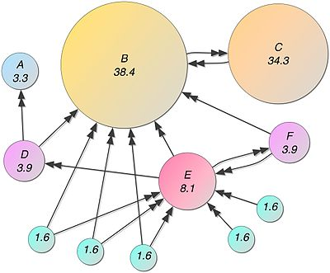<https://en.wikipedia.org/wiki/PageRank>

### **Panda:**

Google Panda Initial Release Date: February 23, 2011

The stated purpose of the Google Panda algorithm update was to reward high-quality websites and diminish the presence of low-quality websites in Google’s organic search engine results. It was also initially known as "Farmer." According to Google, Panda’s initial rollout over the course of several months affected up to 12 percent of English language search results. It get 28 data updates between 2011 and 2015.

**Triggers for Panda:**

The Panda algorithm update addressed a number of problematic phenomena in Google SERPs, including:

* Thin content:   
  Weak pages with very little relevant or substantive text and resources, such as a set of pages describing a variety of health conditions with only a few sentences present on each page.
* Duplicate content:   
  Copied content that appears on the Internet in more than one place. Duplicate content issues can also happen on your own website when you have multiple pages featuring the same text with little or no variation. For example, a chimney sweep company might create 10 pages, one for each city the business serves, with content that is nearly identical on all of the pages with only the city names swapped out (e.g. “We clean chimneys in Denver” on one page and “We clean chimneys in Boulder” on the next, and “We clean chimneys in Aspen” on the next).
* Low-quality content:   
  Pages that provide little value to human readers because they lack in-depth information.
* Lack of authority / trustworthiness:   
  Content produced by sources that are not considered definitive or verified. A Google rep stated that sites aiming to avoid Panda’s impact should work to become recognized as authorities on their topic and entities to which a human user would feel comfortable giving their credit card information.
* Content farming:   
  Large numbers of low-quality pages, often aggregated from other websites. For example, of a content farm might be a website that employs large numbers of writers at a low wage to create short articles covering a vast variety of search engine queries, producing a body of content that lacks authority and value to readers because its core purpose is simply to gain search engine rankings for every conceivable term.
* Low-quality user-generated content (UGC):   
  An example of this type of low-value User Generated Content would be a blog that publishes guest blog posts that are short, full of spelling and grammatical errors and lacking in authoritative information.
* High ad-to-content ratio: Pages made up mostly of paid advertising rather than original content.
* Low-quality content surrounding affiliate links: Poor content around links pointing to paid affiliate programs.
* Websites blocked by users:   
  Sites that human users are either blocking directly in the search engine results or by using a Chrome browser extension to do so, indicating low quality.
* Content mismatching search query:   
  Pages that "promise" to deliver relevant answers if clicked on in the search results, but then fail to do so. For example, a website page might be titled "Coupons for Whole Foods" but when clicked on, there might be no coupons or there might just be a page of ads, leading to disappointment.

**How to recover from Panda:**

* Abandoning content farming practices
* Overhauling website content for quality, usefulness, relevance, trustworthiness and authority
* Revising the ad/content or affiliate/content ratio so that pages are not dominated by ads or affiliate links
* Ensuring that the content of a given page is a relevant match to a user’s query
* Removing or overhauling duplicate content
* Careful vetting and editing of user-generated content and ensuring that it is original, error-free and useful to readers, where applicable
* Using the Robots noindex, nofollow command to block the indexing of duplicate or near-duplicate internal website content or other problematic elements

Reference: <https://moz.com/learn/seo/google-panda>

### **Penguin:**

A

### **Humming Bird:**

A

### **Pigeon:**

A

### **Rank Brain:**

A

### **Mobile Gedeon:**

A

### **Possum:**

A

### **Fred:**

A

### **Bert:**

A

### **2020 updates:**

A

### **Javascript SEO:**

A

## **Modern SEO Mistakes:**

A

## **Modern SEO Factors:**

A

# **Project Parts:**

A

## **Authentication System:**

A

## **Blog:**

A

## **Virtual Classroom Environment:**

A